SIMATS ENGINEERING
CSA6303- Threat Intelligence and Network Security
A1-Threat Intelligence Report
Assessment Questions
Subject | Threat Intelligence | Total Marks | 50
Questions | 5 (all compulsory) | Marks per Question | 10
Reg. No |  | Name
Faculty | Dr.V.Parthipan | Slot | A
Instructions: Answer all questions. Each question carries 5 marks. Support answers with examples and diagrams where appropriate.
CO3: Perform threat analysis using intelligence models and utilize industry tools for monitoring and detection.

Code of Conduct:

I ____________________ (Name / Reg No) certify that this submission is my original work and that I have adhered to the guidelines specified for this assessment. I understand that any violation of academic integrity rules will result in disciplinary action.

Signature of Student

Questions :
- Threat Hunting Techniques: An organization suspects that an attacker has gained unauthorized access to its internal network. The security team observes unusual login times, unexpected processes, and connections to unfamiliar external servers. Describe the proactive threat-hunting techniques you would use to investigate the activity and identify potential threats. [10]
- SIEM Tools and Security Monitoring : A company implements a Security Information and Event Management (SIEM) system to monitor its network. The system generates multiple alerts about suspicious login attempts and unusual outbound connections. Explain how the SIEM system can collect and analyze security events, correlate alerts, and help security analysts prioritize potential threats. [10]
- Security Monitoring and Anomaly Detection: A company's security monitoring dashboard identifies a sudden increase in outbound network traffic during non-working hours. The activity originates from a database server that normally transfers only small amounts of data. Explain how you would investigate the anomaly, identify possible data exfiltration, and recommend suitable monitoring and prevention measures. [10]
- Tools Used in the IT Industry for Threat Hunting: An IT organization suspects that malware has infected several employee workstations. The security team has access to SIEM software, endpoint detection tools, network traffic analyzers, and vulnerability scanners. Select suitable tools for investigating the incident and explain how each tool can help identify, analyze, and contain the threat. [10]
- Integrated Threat Hunting and Incident Reporting: A company detects suspicious user logins, connections to a malicious domain, and an unknown process running on an employee workstation. The security team uses Splunk or the ELK Stack to analyze logs and a threat intelligence platform to verify suspicious indicators. Describe the complete threat-hunting process, including data collection, log correlation, threat investigation, malware analysis if required, risk assessment, and preparation of a threat-hunting report with recommended remediation actions.

Question 1: Threat Hunting Techniques [10 Marks]
1. Proactive Threat Hunting Approach
When anomalous behaviors are detected, reactive alerting is supplemented by structured threat hunting using Hypothesis-Driven Hunting and Indicator of Behavior (IoB) Analysis.
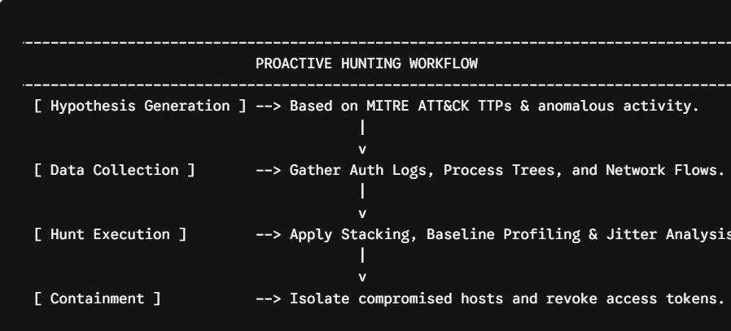2. Core Threat Hunting Techniques Applied
- Investigating Unusual Login Times (Compromised Credentials):
  - Technique: Time-Series Baseline Profiling.
  - Execution: Aggregate user authentication logs (Windows Event ID 4624/4625). Establish standard working-hour baselines over 30 days. Off-hours logins (e.g., 03:00 AM) or geographical anomalies (Impossible Travel across locations within minutes) flag high risk.
- Investigating Unexpected Processes (Execution & Persistence):
  - Technique: Least Frequency of Occurrence (Stack Counting) & Process Tree Analysis.
  - Execution: Analyze Sysmon Event ID 1 / Event ID 4688. Identify rare process names, anomalous execution paths (e.g., svchost.exe running from AppData), and suspicious parent-child relationships (e.g., winword.exe spawning powershell.exe).
- Investigating Unfamiliar External Connections (Command & Control):
  - Technique: Network Traffic Stacking & Beaconing Analysis.
  - Execution: Evaluate NetFlow data and Proxy/DNS logs (Sysmon Event ID 22). Calculate connection frequency and Delta Time (Jitter). Regular automated outbound requests (e.g., HTTPS connection every 60 seconds) indicate active C2 beaconing.
3. Execution Summary
Phase | Core Objective | Tools / Data Sources Used
Data Aggregation | Collect multi-source host and network logs. | Sysmon, WinEvent, NetFlow, Proxy Logs
Pattern Analysis | Map behavioral patterns to ATT&CK tactics. | Sigma Rules, YARA, Splunk SPL
Investigation | Inspect command lines and hash reputations. | EDR Console, VirusTotal, Volatility
Remediation | Sever host connectivity and reset accounts. | Firewall ACLs, Active Directory / IAM

Question 2: SIEM Tools and Security Monitoring [10 Marks]
1. SIEM Architecture and Log Processing Workflow
A Security Information and Event Management (SIEM) system ingests unstructured log data across an enterprise network, normalizes it, correlates events, and alerts security analysts.
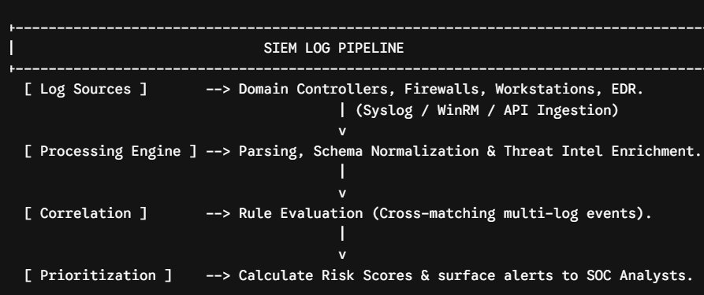2. Functional Stages
- Ingestion & Normalization: Agents parse raw text logs into unified fields (e.g., Elastic Common Schema) extracting key attributes (source.ip, destination.ip, event.code).
- Threat Intel Enrichment: Automatically cross-references IP/domain data with active threat feeds (STIX/TAXII) to tag high-risk indicators.
3. Correlation Logic Example
Rules link discrete logs to identify complex attacks.
- Rule Logic: IF $>5$Failed Logins occur within 2 minutes on Host $A$, FOLLOWED BY a Successful Login, FOLLOWED BY Host $A$sending $>500\text{ MB}$outbound to an unknown external IP within 30 minutes, THEN raise a Critical Alert.
DEFINE RULE: Compromised Account Exfiltration Sequence
EVENT 1: Auth_Log (action == "FAILED" AND count >= 5 WITHIN 120s)
EVENT 2: Auth_Log (action == "SUCCESS" AND user == EVENT_1.user WITHIN 300s)
EVENT 3: Firewall_Log (source_ip == EVENT_2.host AND bytes_sent > 500MB WITHIN 1800s)
ACTION: Trigger Alert ("CRITICAL: Account Takeover & Exfiltration"), Isolate Host.
4. Threat Prioritization Model
SIEM uses risk scoring to eliminate false positives and prioritize high-risk alerts:
$$\text{Risk Score}=\text{Asset Criticality (1-10)}×\text{Threat Severity (1-10)}×\text{Confidence (0-1)}$$
$$\text{Risk Score}=\text{Asset Criticality (1-10)}×\text{Threat Severity (1-10)}×\text{Confidence (0-1)}$$
- Example: High-Value DB Server (10) $×$Exfiltration Activity (10) $×$High Confidence (0.95) = 95.0 (Critical Priority).

Question 3: Security Monitoring and Anomaly Detection [10 Marks]
1. Investigation Workflow for Database Server Anomaly
An unexpected spike of outbound traffic ($>15\text{ GB}$) from a Database Server (10.0.4.15) during non-working hours requires immediate host and network isolation and analysis.
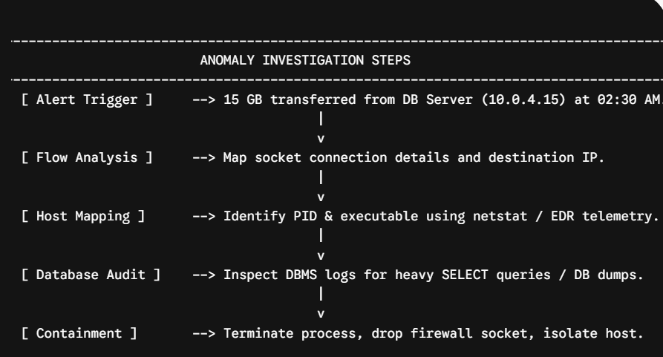2. Detailed Technical Investigation Steps
- Network Connection Analysis: Examine NetFlow logs for destination IP/port details (198.51.100.77:443). Check domain reputation to see if the target belongs to cloud storage providers or known C2 servers.
- Process-to-Socket Mapping: Run host diagnostics using EDR or netstat -ano to map the socket connection to a specific PID. Determine if an authorized database process (mysqld.exe) or a hijacked binary (powershell.exe, rclone.exe) initiated the transfer.
- Database Log Audit: Inspect DBMS audit logs for unauthorized SQL queries (SELECT *) or execution of database dumping tools (mysqldump) corresponding to the transfer window.
- Staging File Discovery: Check Sysmon Event ID 11 for compressed archive creations (.zip, .7z) in temporary directories (C:\Windows\Temp\) prior to transfer.
3. Monitoring & Prevention Controls
Control Domain | Recommended Action
UEBA Monitoring | Set behavioral alert thresholds when host outbound volume exceeds $3σ$of baseline.
Egress Filtering | Implement strict network egress rules blocking direct outbound internet access from DB servers.
Application Control | Enforce AppLocker/WDAC policies to prevent execution of unauthorized archiving or staging tools.
Data Loss Prevention | Deploy network DLP controls to inspect and block unauthorized large encrypted file transfers.

Question 4: Tools Used in the IT Industry for Threat Hunting [10 Marks]
1. Security Tool Suite Overview
Category | Primary Tools | Role in Incident Investigation
SIEM | Splunk, ELK Stack | Aggregates system logs, correlates host/network data, and builds incident timelines.
EDR | CrowdStrike Falcon, MS Defender | Analyzes host process trees, inspects memory artifacts, and isolates endpoints.
NTA / NDR | Zeek, Wireshark | Conducts deep packet inspection (DPI) to identify C2 traffic and exfiltration volume.
Vulnerability Scanner | Nessus, Qualys | Identifies missing patches, misconfigurations, and initial entry vectors (CVEs).
2. Multi-Tool Investigation Architecture
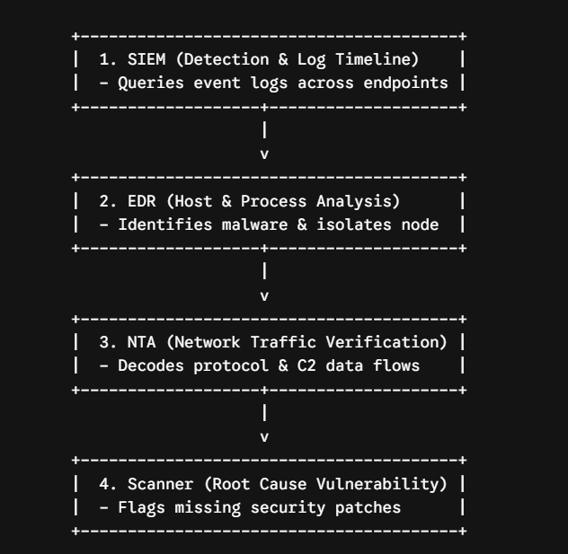

3. Incident Investigation Workflow
- SIEM Identification: Run search queries across indexed host logs to identify endpoints running anomalous commands:
Splunk SPL
index=endpoint process_name=powershell.exe | stats count by host, command_line | where count < 5
- EDR Host Containment: Inspect the host process tree (cmd.exe $→$powershell.exe $→$rundll32.exe). Extract the payload file hash (SHA-256) and execute network isolation on compromised hosts via the EDR console.
- NTA Traffic Inspection: Filter packet captures for traffic to malicious external domains (malicious-c2-domain[.]com). Add identified C2 IP addresses to firewall blacklists.
- Vulnerability Scanning: Run targeted credentialed vulnerability scans across the workstation subnet using Nessus to pinpoint unpatched vulnerabilities (e.g., CVE-2023-36884) used for initial delivery.

Question 5: Integrated Threat Hunting and Incident Reporting [10 Marks]
1. Threat Hunting & Incident Lifecycle
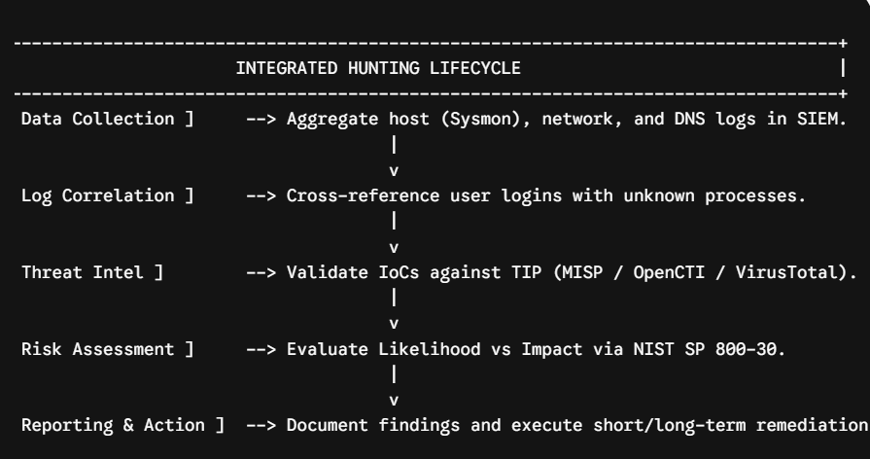2. Core Execution Steps
- Log Correlation (Splunk SPL):
Splunk SPL
index=security (EventCode=4624 OR EventCode=1 OR sourcetype="stream:dns")
| stats values(query) as dns_queries, values(Image) as spawned_processes by User, host
| search dns_queries="*malicious-domain.com*"
- Threat Intel Verification: Validate extracted IoCs (Domain: update-service-check[.]com, SHA-256 hash) against threat intelligence platforms to confirm attribution and threat severity.
- Risk Assessment (NIST SP 800-30):
$$\text{Risk Level}=\text{Likelihood Score (5/5)}×\text{Impact Score (4/5)}=20\text{ (Critical Risk)}$$
$$\text{Risk Level}=\text{Likelihood Score (5/5)}×\text{Impact Score (4/5)}=20\text{ (Critical Risk)}$$
3. Formal Threat Hunting & Incident Report
==================================================================
INCIDENT THREAT HUNTING REPORT
==================================================================
DOCUMENT ID : TH-2026-088 DATE : Oct 28, 2026
TARGET HOST : WS-FIN-044 (10.0.2.88) AUTHOR : SOC Lead Analyst
INCIDENT TYPE: Malware Infection & C2 Beaconing SEVERITY : HIGH / CRITICAL
=================================================================
1. EXECUTIVE SUMMARY
--------------------------------------------------------------------------------------------------------------
The SOC identified a malware infection on host WS-FIN-044 executing from AppData\Local\Temp.
The process established persistent C2 communication with a malicious external domain.
Host network access was isolated and containment actions were successfully executed.
2. CHRONOLOGICAL INCIDENT TIMELINE
---------------------------------------------------------------------------------------------------------------
+-------------------------+--------------------------------------------------------------------------------+
| Timestamp (UTC) | Event Description |
+-------------------------+--------------------------------------------------------------------------------+
| 2026-10-28 01:15:02 | Off-hours successful authentication on host WS-FIN-044. |
| 2026-10-28 01:17:40 | Process Creation (Sysmon ID 1): Execution of `winupdate.exe`. |
| 2026-10-28 01:18:10 | DNS Lookup: Query to malicious domain `update-service-check`. |
| 2026-10-28 01:20:00 | Active C2 Beaconing: Outbound traffic established over 443. |
| 2026-10-28 02:00:00 | Host Containment: System network access severed via EDR. |
+-------------------------+--------------------------------------------------------------------------------+

3. INDICATORS OF COMPROMISE (IoCs)
--------------------------------------------------------------------------------------------------------
* Domain Indicator : update-service-check[.]com
* External IPv4 : 198.51.100.44
* File Name / Path : C:\Users\jdoe\AppData\Local\Temp\winupdate.exe
* SHA-256 Hash : e3b0c44298fc1c149afbf4c8996fb92427ae41e4649b934ca495991b7852b855

4. RECOMMENDED REMEDIATION & PREVENTIVE ACTIONS
--------------------------------------------------------------------------------------
Immediate Remediation:
1. Revoke active directory credentials for user account 'jdoe' and terminate sessions.
2. Perform remote forensic re-imaging of workstation host WS-FIN-044.
3. Block IPv4 198.51.100.44 and domain update-service-check[.]com at core firewalls.

Long-Term Prevention:
1. Enforce AppLocker rules blocking binary execution from user temp directories.
2. Enforce Multi-Factor Authentication (MFA) with number matching across all users.

==================================================================
END OF REPORT -- SIMATS ENGINEERING SOC ASSESSMENT SUBMISSION
==================================================================

